STUDENT NO: ST10470570

Name: Roberto Carlos Dondo

Module: WEDE5020

PORTFOLIO OF EVIDENCE: PART 1

Lecture: MR Motau

Due Date: 07 April 2025

Table of Contents

Website Choose and Description 3

Business Description of Dondo Water NGO 3

Assets 4

Webpages and Content 6

List of Webpages and structure 6

Homepage 6

About Us 6

Services 6

News 7

Contact Us 7

The entire estimated budget 7

Bibliography 9

# Website Choose and Description

# Business Description of Dondo Water NGO

A non-profit organization called Dondo Water is dedicated to provide rural communities and people without access to clean drinking water dependable, sustainable clean water solutions. We enable these communities to enhance their general quality of life, health, and education by guaranteeing a consistent supply of water. Our goal is to establish a society in which everyone, everywhere, has access to safe, clean water, promoting growth, well-being, and new opportunities for everybody.

Through important projects including planning and constructing water delivery systems like boreholes, wells, and rainfall harvesting structures to ensure sustainable access to water, Dondo Water implements workable and long-lasting solutions to solve water scarcity in underprivileged communities. By offering and maintaining reasonably priced, low-maintenance filtration and purification systems, we guarantee the safety of the water. Additionally, we provide instructional programs on sanitation, hygiene, and water conservation to strengthen local communities. We seek to build sustainable water infrastructure and make the biggest effect in the places that need it most by working with regional administrations and global organizations.

Through quantifiable objectives, such as installing and maintaining water systems in 100 rural communities within the first five years, educating at least 10,000 people on best practices for hygiene and water conservation within the next two years, and forming alliances with NGOs, governments, and businesses to broaden our reach and guarantee long-term sustainability, Dondo Water is committed to creating a lasting impact. We measure the number of individuals served, the installation of water systems, and the advancements in economic and health results in order to monitor our success. We want to bring about significant, long-lasting change in marginalized areas by holding ourselves accountable.

We at Dondo Water think that having access to clean water is both a basic human right and a driving force for social and economic advancement. We work to create a future in which no community is left without this vital resource by consistently innovating and partnering with committed partners. We're still dedicated to growing our influence and changing lives via sustainable water solutions, with the help of funders, volunteers, and stakeholders. By working together, we can make it possible for everyone to have access to clean, safe water.

## Assets

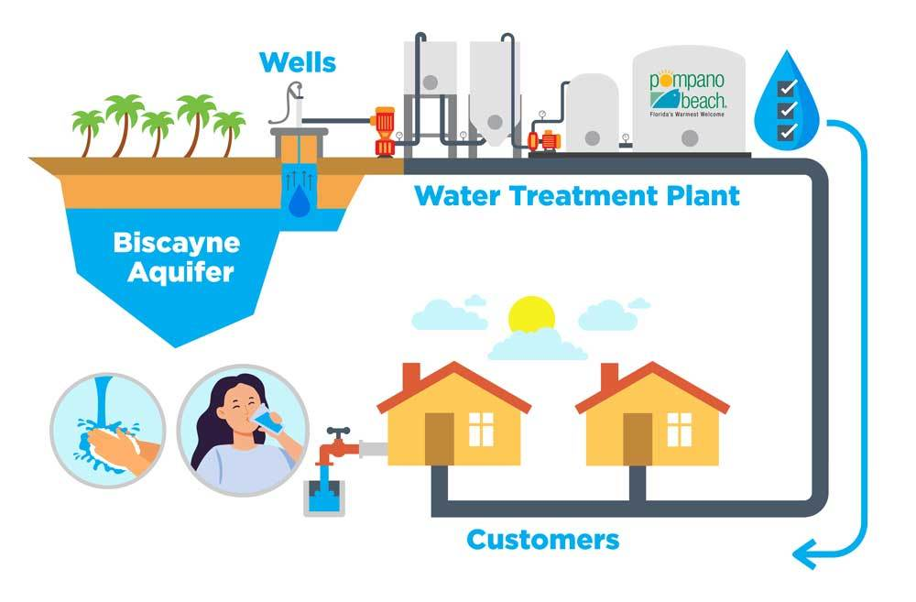

## Webpages and Content

### List of Webpages and structure

### Homepage

1. Page Heading: Welcome to Dondo Water
2. Links to other pages (Home, About Us, Services, News, Contact Us)
3. Brief description of Dondo Water
4. Vision of Dondo Water detailed
5. Image of What We Do
6. Copyright/year

### About Us

1. Page heading: About Us
2. Links to other pages (Home, About Us, Services, News, Contact Us)
3. Small introduction about Dondo Water
4. Information about what we can do together, our impact in South Africa, our promises to you and donations for you to give including a donation button soon to be fixed, and finally about our team (Organisation, 2022)
5. Image of About Us
6. Copyright/year

### Services

1. Page heading: Our Services
2. Links to other pages (Home, About Us, Services, News, Contact Us)
3. Heading Core Services and descriptions of them with emojis included to express them
4. Image of Our Services
5. Copyright/year

### News

1. Page heading: News
2. Links to other pages (Home, About Us, Services, News, Contact Us)
3. News Description of Challenges faced by South Africa most recently and back then and responses to these challenges and what our Organisation Dondo Water is doing
4. Image of News Showing a Mountain Describing the challenges we need to overcome
5. Copyright/year

### Contact Us

1. Page Heading: Contact Us
2. Links to other pages (Home, About Us, Services, News, Contact Us)
3. Contact Details (Email, Phone, location)
4. Send us a Message option
5. Copyright/year

The Entire estimated budget

It ranges from R250,000 to R900,000, depending on scale and automation degree.

Operational Costs Per Month (After Launch)

Water, bottles, labels, utilities, and other production costs range from R50,000 to R200,000.

Advertising and Marketing: R5,000 to R20,000

Labor & Salaries: R30,000 to R100,000.

Delivery & Logistics: R20,000 to R80,000

Additional costs: R10,000 to R30,000

Monthly Operating Cost Estimate: R100,000 to R400,000

Important Elements Impacting the Budget:

Scale of Production: Although it costs more, automated bottling on a large scale is more effective.

Water Source: Although installing a borehole water system is more expensive, it saves money over time.

Purification System: Basic filtering is less expensive than reverse osmosis.

Marketing Plan: Compared to traditional media, digital marketing is less expensive.

Packaging Quality: Generic bottles are less expensive than custom-branded ones.

# Bibliography

Organisation, W. H. (2022). *World Health Organisation*. Retrieved from World Health Organisation: https://www.who.int/publications

S, H. (2019). *Thirst: A Story of Redemption, Compassion, and a Mission to Bring Clean Water to the World. Currency.*

Water, C. (2024). *Charity:Water*. Retrieved from Charity Water: https://www.charitywater.org